NAMA : FAISAL MUCHSIN

NIM : 071911633078

MATA KULIAH : ETS201-ETIKA PELAYANAN

TANGGAL : 18 SEPTEMBER 2020

**Alamat TikTok dan Instagram**

**Tiktok : @faisalmuchsinn /** [**https://vt.tiktok.com/ZS55yyjY/**](https://vt.tiktok.com/ZS55yyjY/)

**Instagram : @faisalmuchsinn /** [**https://www.instagram.com/faisalmuchsinn/**](https://www.instagram.com/faisalmuchsinn/)

**Post : https://www.instagram.com/p/CFTBagxBPk6/**

**BUKTI CAPTURE INSTAGRAM**

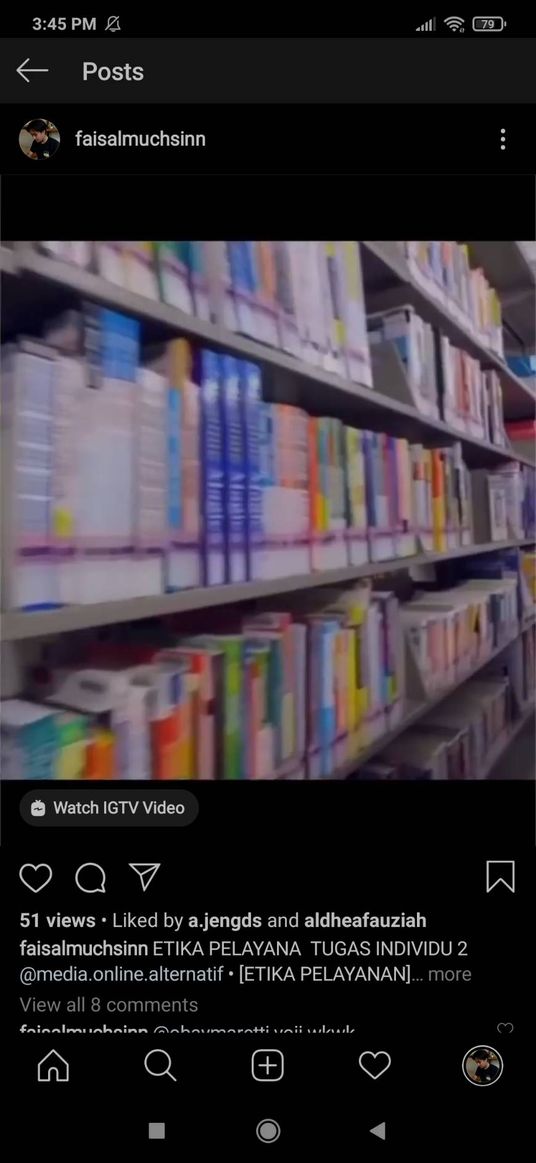

**Sumber Media :**

**https://www.rumah.com/berita-properti/2016/7/131389/10-interior-perpustakaan-paling-memukau-di-dunia**

**http://seputarperpus.blogspot.com/2017/01/perpustakaan-sekolah-yang-ideal-di-masa.html?m=1**

**https://m.youtube.com/watch?v=d4fhNRqiFZ8**

**https://m.youtube.com/watch?v=BFxZ15xXVRk**